# Measurable and Progress from maladaptive behaviors.

|  |  |  |  |  |  |
| --- | --- | --- | --- | --- | --- |
| Maladaptive Behaviors | Baseline Date:2017-09-25to2017-09-27 | Current average per week (3/31/2020) | % of Reduction(BL-average/ BL)*100 | Status | Updated STO (3/31/2020) |
| Physical Aggression | 21 incidents per weeks | 20 incidents per week. | 5% | In progress | Sto1(MASTERED 2018-08-04). Sto2(MASTERED 2020-01-18). Currently: STO 3(Initiated 2/1/2020) |
| Tantrum | 35 incidents per weeks | 32 incidents per week. | 10% | In progress | Sto1(MASTERED 2018-03-17). Sto2(MASTERED 2020-02-29). Currently: STO 3(Initiated 3/1/2020) |
| Elopement | 21 incidents per weeks | 20 incidents per week. | 4% | In progress | Sto1(MASTERED 2018-08-04). Sto2(MASTERED 2019-12-28). Currently: STO 3(Initiated 1/1/2020) |
| Disruption | 42 incidents per weeks | 38 incidents per week. | 9% | In progress | Sto1(MASTERED 2018-03-24). Sto2(MASTERED 2018-06-16). Sto3(MASTERED 2018-06-16). Sto4(MASTERED 2020-01-25). Currently: STO 5(Initiated 2/1/2020) |
| Task Refusal | 56 incidents per weeks | 47 incidents per week. | 16% | In progress | Sto1(MASTERED 2018-08-11). Sto2(MASTERED 2020-01-25). Currently: STO 3(Initiated 2/1/2020) |
| Eating non edible | 28 incidents per weeks | 25 incidents per week. | 12% | In progress | Sto1(MASTERED 2018-09-01). Sto2(MASTERED 2019-12-28). Currently: STO 3(Initiated 1/1/2020) |
| Mouthing | 35 incidents per weeks | 29 incidents per week. | 17% | In progress | Sto1(MASTERED 2018-03-24). Sto2(MASTERED 2018-08-25). Sto3(MASTERED 2020-02-29). Currently: STO 4(Initiated 3/1/2020) |
| Stereotype behaviors | 63 incidents per weeks | 56 incidents per week. | 11% | In progress | Sto1(MASTERED 2019-08-10). Sto2(MASTERED 2019-11-02). Currently: STO 3(Initiated 12/1/2019) |
| Self-injurious behavior | 56 incidents per weeks | 47 incidents per week. | 16% | In progress | Sto1(MASTERED 2019-08-31). Sto2(MASTERED 2019-11-30). Currently: STO 3(Initiated 12/1/2019) |
| Total of Reduction (%) | - | - | - | - | 11.6468253968 |

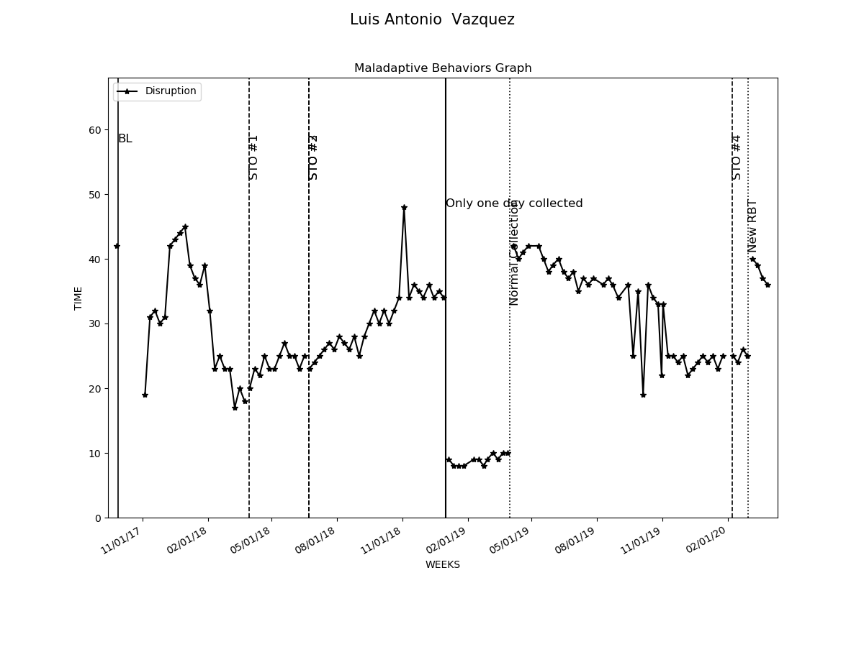

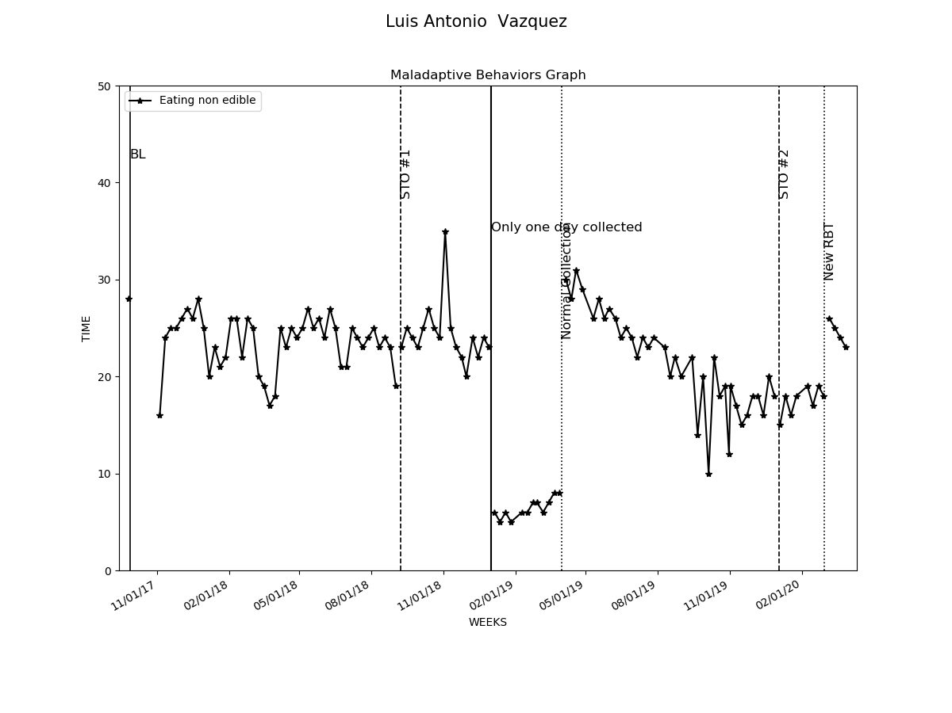

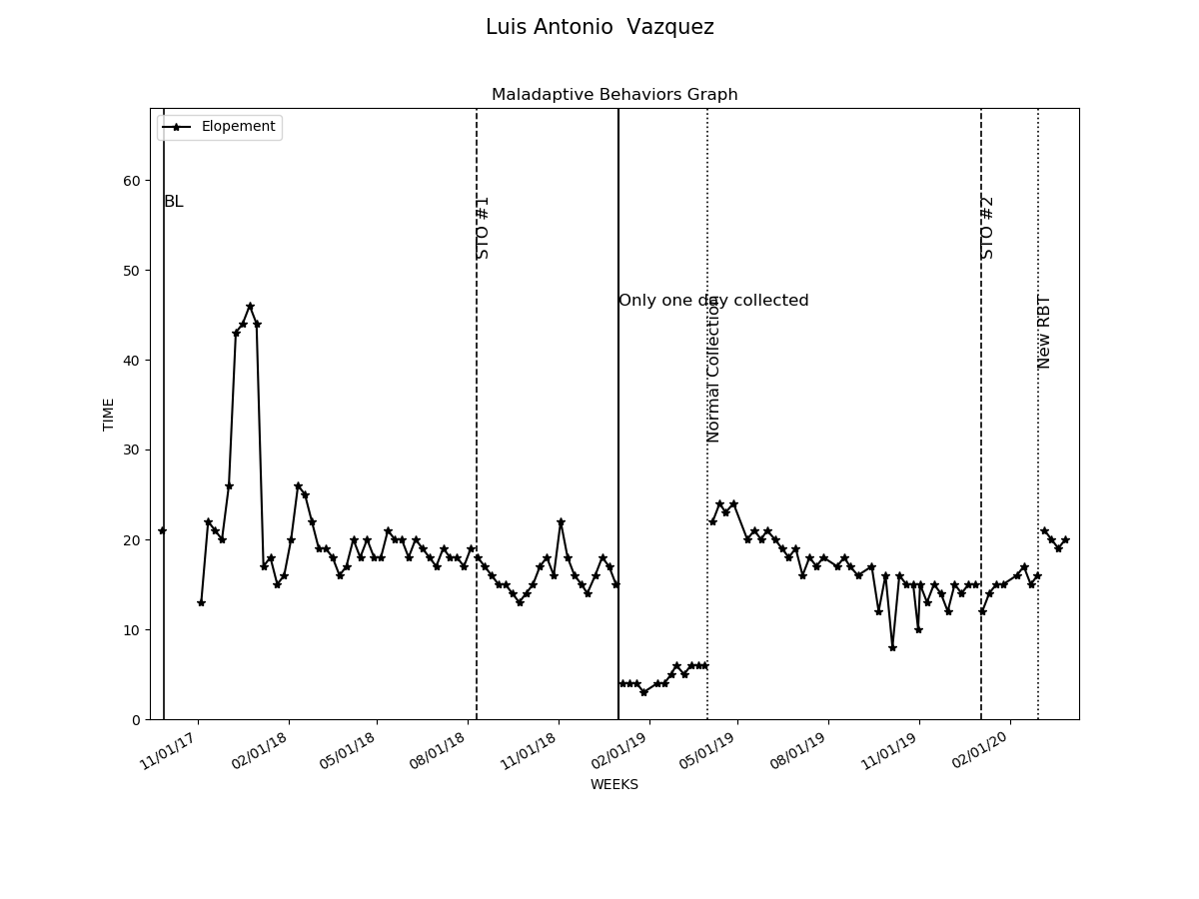

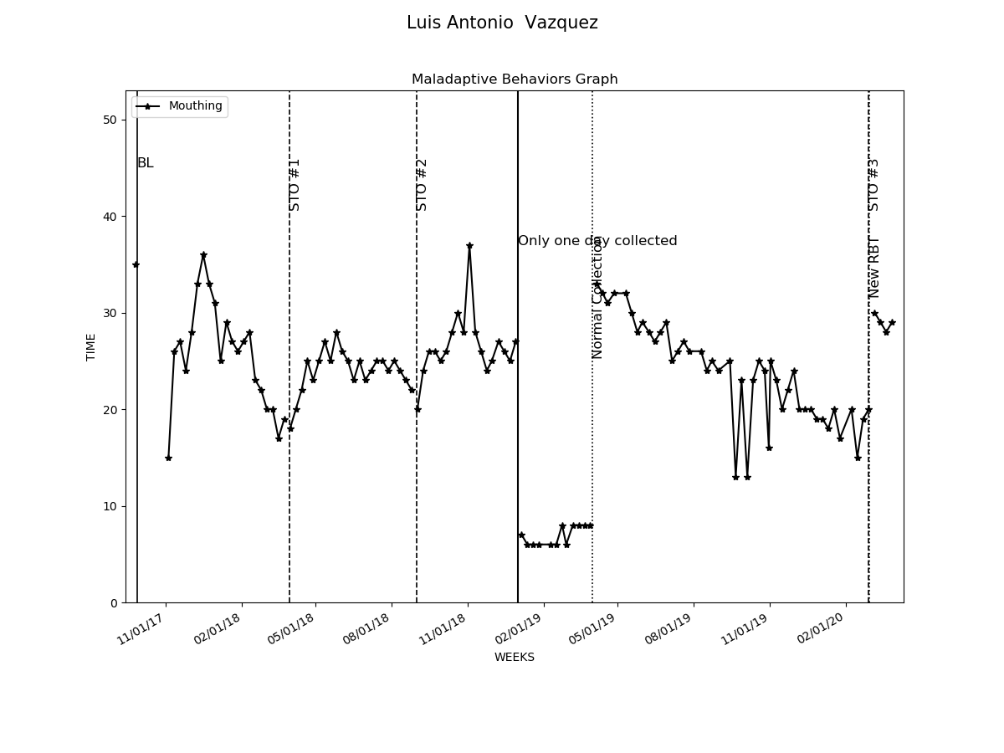

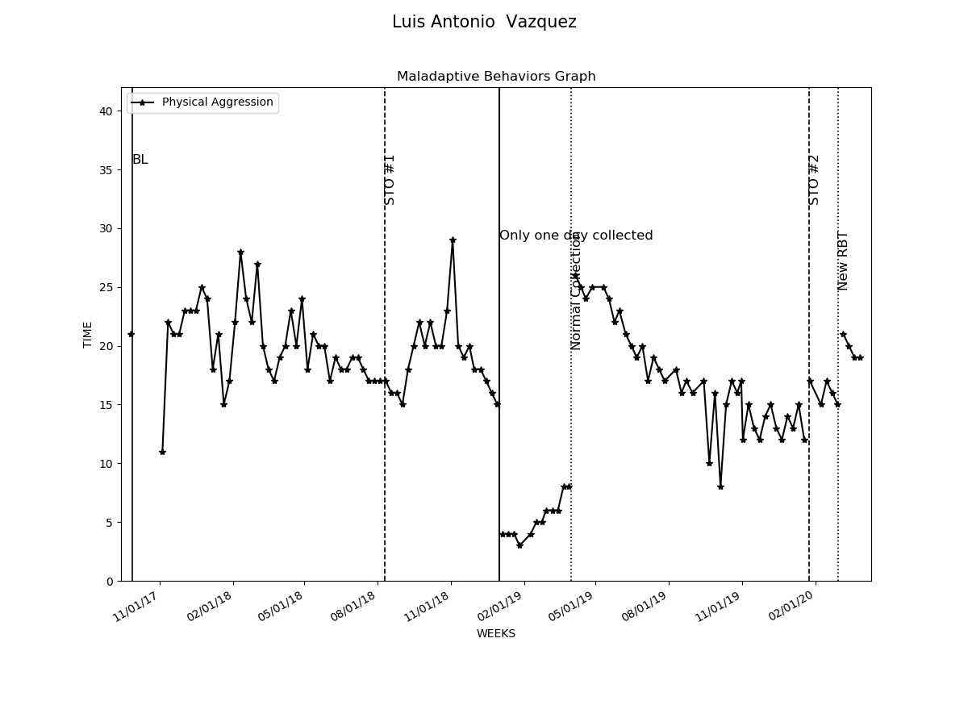

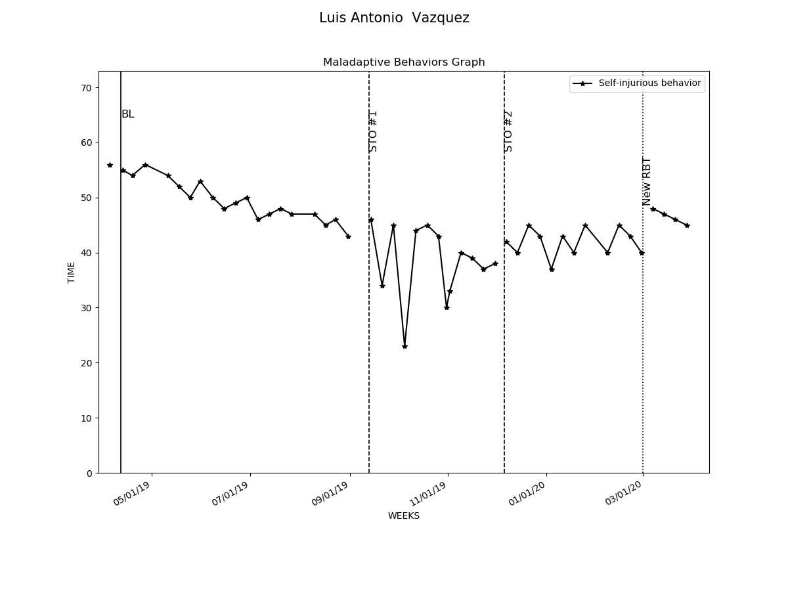

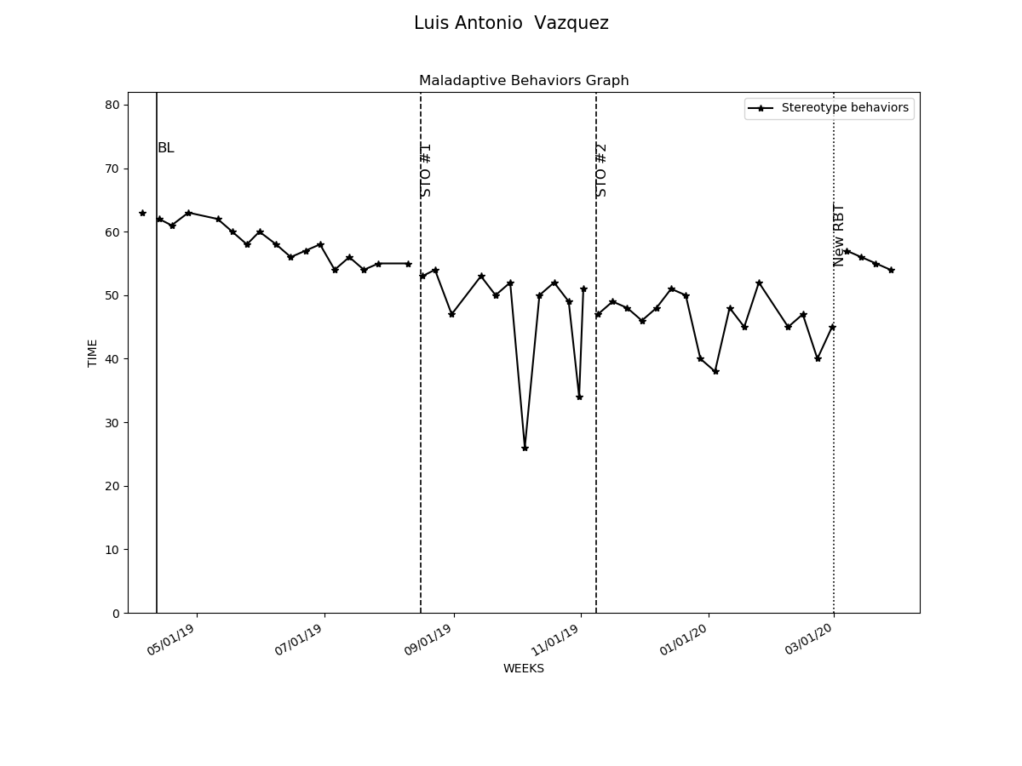

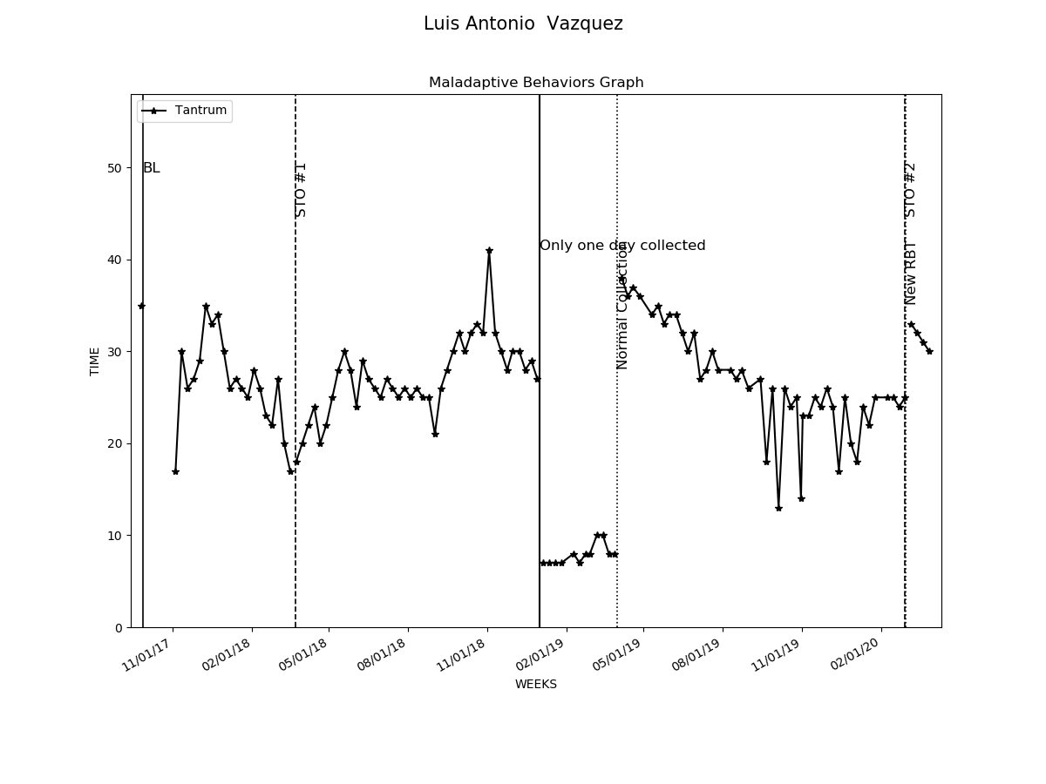

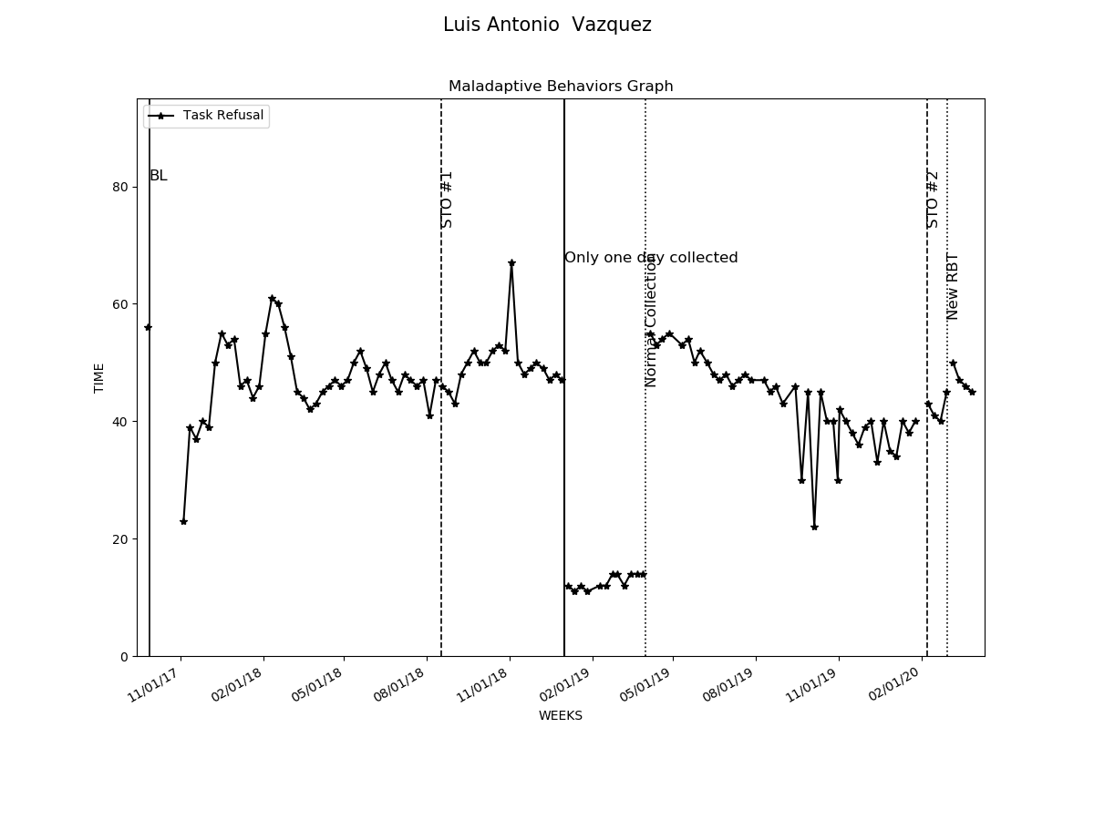

# Graphs Replacement and Interventions

|  |  |  |  |  |
| --- | --- | --- | --- | --- |
| Replacements and Programs | Baseline Date:2017-11-04to2017-11-07 | Current average per week (3/31/2020) | Status | Updated STO (3/31/2020) |
| 1- Request Break | 3% | 32% | In progress | Sto1(MASTERED 2018-08-18). Sto2(MASTERED 2020-02-29). Currently: STO 3(Initiated 3/1/2020) |
| 2- Request Attention | 13% | 33% | In progress | Sto1(MASTERED 2018-08-18). Sto2(MASTERED 2020-01-25). Currently: STO 3(Initiated 2/1/2020) |
| 3- Request Tangible | 0% | 34% | In progress | Sto1(MASTERED 2018-06-23). Sto2(MASTERED 2020-01-25). Currently: STO 3(Initiated 2/1/2020) |
| 4- Follow instructions | 0% | 35% | In progress | Sto1(MASTERED 2018-08-18). Sto2(MASTERED 2019-12-28). Currently: STO 3(Initiated 1/1/2020) |
| 5- Wait for Tangible | 0% | 41% | In progress | Sto1(MASTERED 2018-08-18). Sto2(MASTERED 2020-02-29). Currently: STO 3(Initiated 3/1/2020) |
| 6- Social Skills- Initiate and sustain interaction | 3% | 36% | In progress | Sto1(MASTERED 2018-04-28). Sto2(MASTERED 2019-11-23). Currently: STO 3(Initiated 12/1/2019) |
| 7- Social Skills- Taking turns during a play | 0% | 37% | In progress | Sto1(MASTERED 2018-04-21). Sto2(MASTERED 2019-12-28). Currently: STO 3(Initiated 1/1/2020) |
| 8- Social Skills- Sharing toys | 2% | 37% | In progress | Sto1(MASTERED 2018-09-22). Sto2(MASTERED 2020-01-18). Currently: STO 3(Initiated 2/1/2020) |
| 9- Social Skills- Accepting physical prompts | 3% | 36% | In progress | Sto1(MASTERED 2018-08-18). Sto2(MASTERED 2020-01-18). Currently: STO 3(Initiated 2/1/2020) |
| 10- Compliance with activity schedule - Stay on task | 17% | 37% | In progress | Sto1(MASTERED 2018-04-28). Sto2(MASTERED 2018-08-18). Sto3(MASTERED 2018-11-03). Sto4(MASTERED 2018-11-30). Sto5(MASTERED 2019-10-19). Currently: STO 6(Initiated 11/1/2019) |
| 11- Vocal imitation | 4% | 37% | In progress | Sto1(MASTERED 2018-09-08). Sto2(MASTERED 2020-01-18). Currently: STO 3(Initiated 2/1/2020) |
| 12- Motor imitation | 2% | 37% | In progress | Sto1(MASTERED 2018-09-15). Sto2(MASTERED 2020-01-11). Currently: STO 3(Initiated 2/1/2020) |
| 13- Gesture imitation | 5% | 38% | In progress | Sto1(MASTERED 2018-06-23). Sto2(MASTERED 2020-01-18). Currently: STO 3(Initiated 2/1/2020) |
| 14- Matching objects-pictures | 6% | 41% | In progress | Sto1(MASTERED 2018-09-15). Sto2(MASTERED 2020-02-29). Currently: STO 3(Initiated 3/1/2020) |
| 15- Matching colors | 2% | 41% | In progress | Sto1(MASTERED 2018-09-15). Sto2(MASTERED 2020-01-18). Currently: STO 3(Initiated 2/1/2020) |
| 19- Parent Training - Data Collection | 0% | 77% | In progress | Sto1(MASTERED 2019-05-25). Sto2(MASTERED 2019-08-23). Sto3(MASTERED 2020-01-11). Currently: STO 4(Initiated 2/1/2020) |
| 20- Parent Training - Generalization of skills | 0% | 77% | In progress | Sto1(MASTERED 2019-05-25). Sto2(MASTERED 2019-09-28). Sto3(MASTERED 2019-12-21). Currently: STO 4(Initiated 1/1/2020) |

